Lesson 4 – HTML Tables, Lists & Block Elements

[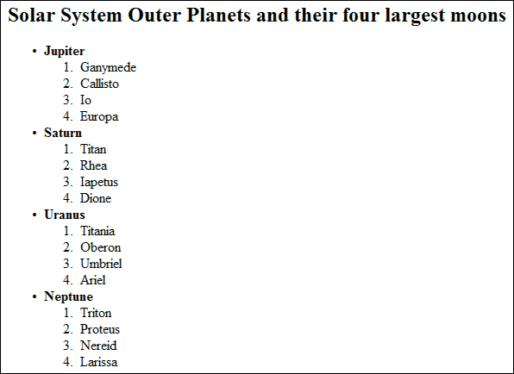](https://www.google.sk/url?sa=i&rct=j&q=&esrc=s&source=images&cd=&cad=rja&uact=8&ved=2ahUKEwje8q6chu3dAhVN3KQKHSmsBWUQjRx6BAgBEAU&url=http%3A%2F%2Fwww.peachpit.com%2Farticles%2Farticle.aspx%3Fp%3D1927738%26seqNum%3D11&psig=AOvVaw1b-iVaL9gxu8t20AZ9-Wvy&ust=1538751267884380)

1. Tables

- tutorial: <https://www.tutorialspoint.com/html/html_tables.htm>

- exercise: create your own school timetable in pure HTML

2. Lists

- tutorial: <https://www.tutorialspoint.com/html/html_lists.htm>

- exercise: create the following list in pure HTML ---------------------------->

3. Block Elements

- tutorial: <https://www.tutorialspoint.com/html/html_blocks.htm>

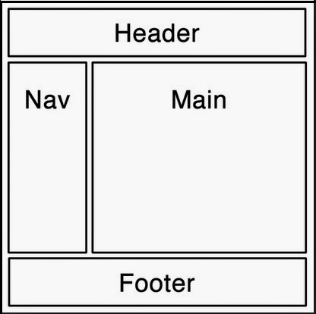

Task:

- Create a basic layout for a webpage using <div> elements.

- Use the document below as a guideline.

- Select custom colors using this [color picker](https://www.w3schools.com/colors/colors_picker.asp).

